# **Snowflake Assignment**

1. Create a file format to handle CSV files, specifying things like the delimiter, whether to skip headers, and other parameters.

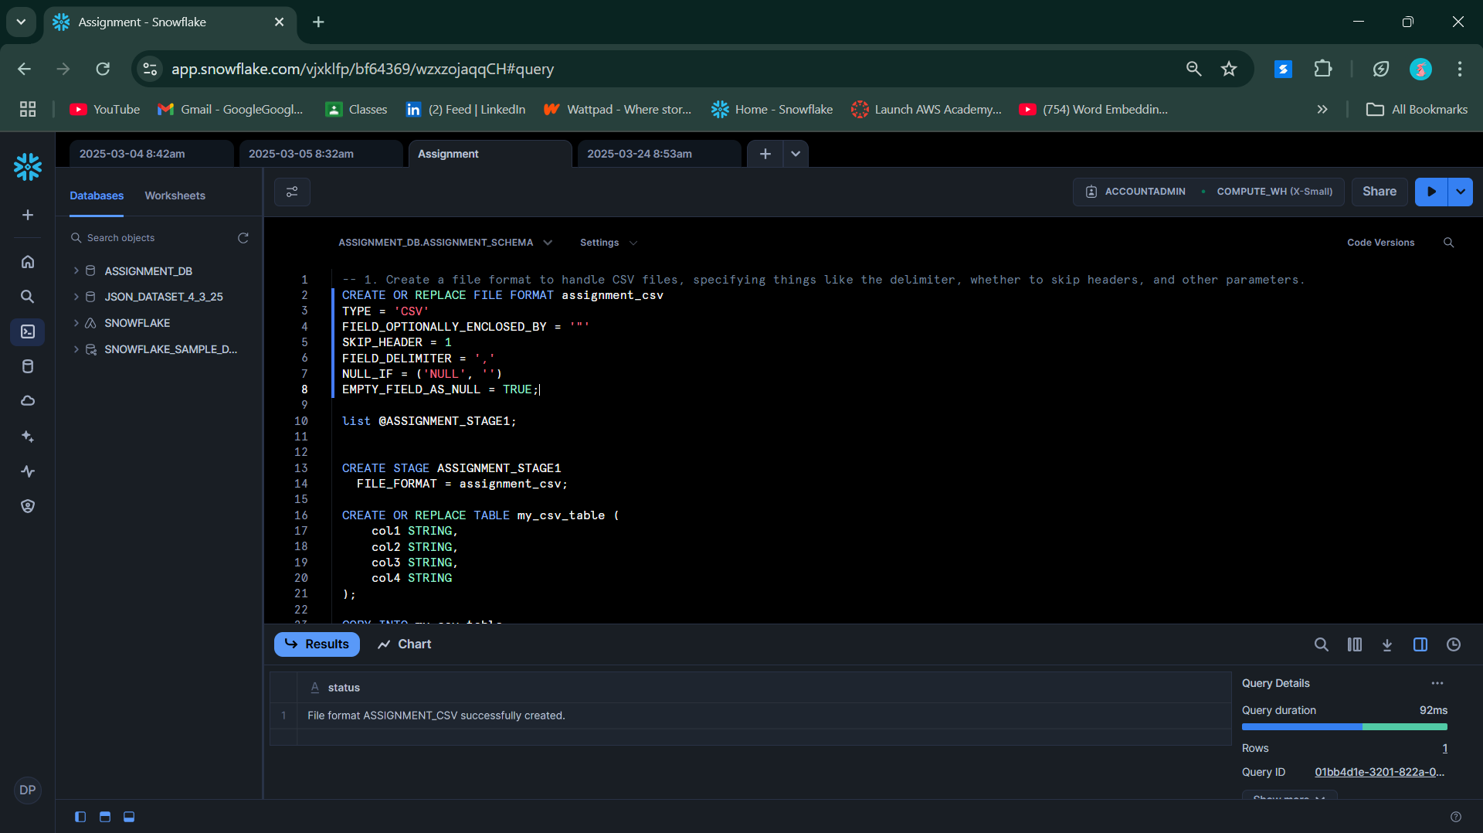

1. Create a file format to handle JSON files.

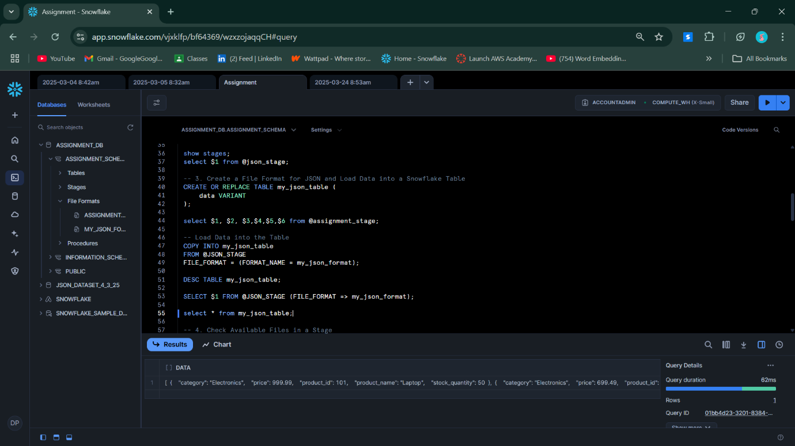

1. Create a file format for JSON files and load data into a Snowflake table.
2. 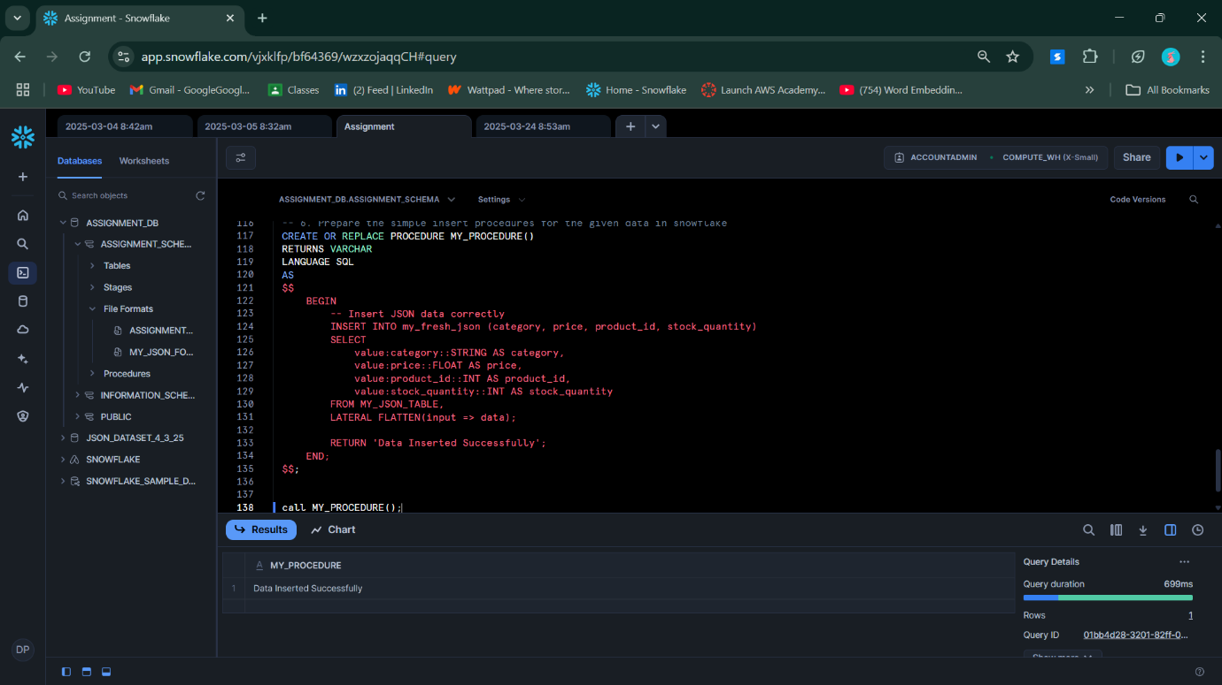
3. 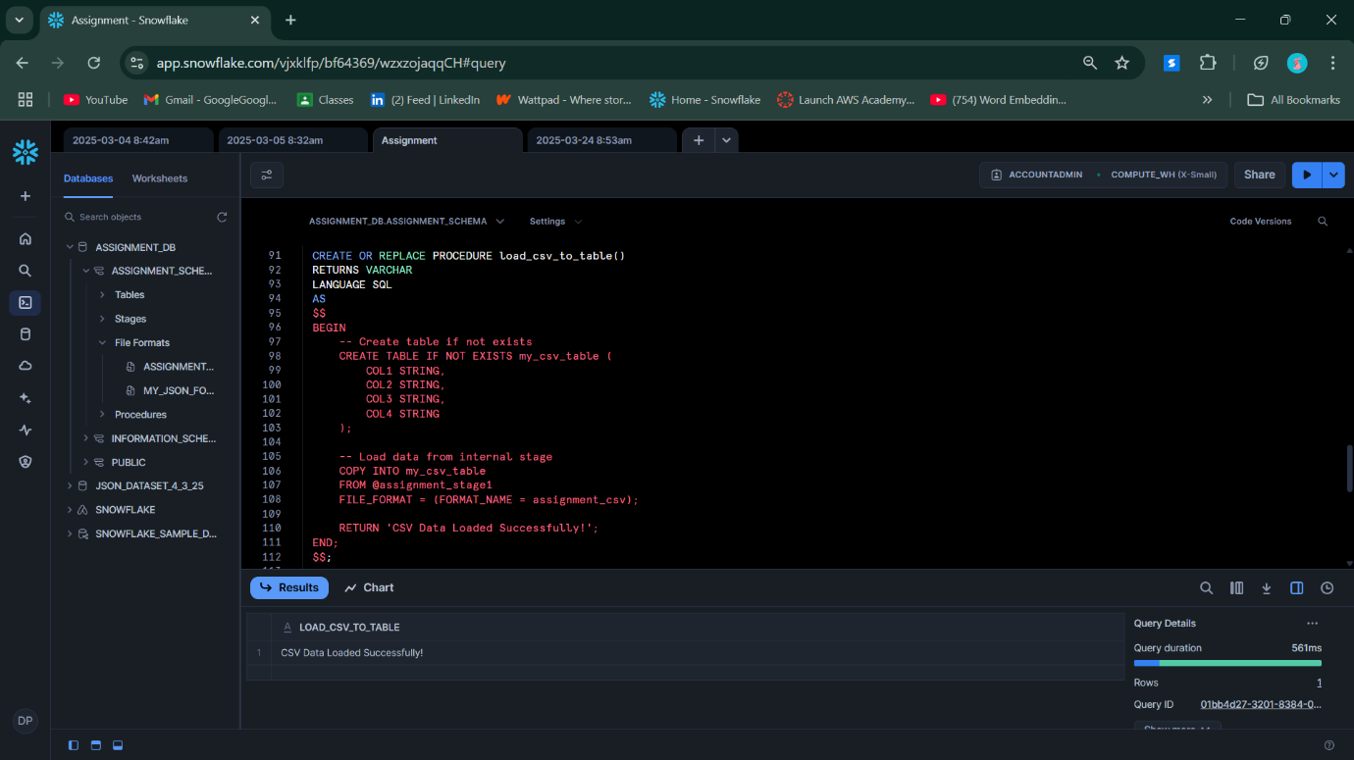
4. 

-- 1. Create a file format to handle CSV files, specifying things like the delimiter, whether to skip headers, and other parameters.

CREATE OR REPLACE FILE FORMAT assignment_csv

TYPE = 'CSV'

FIELD_OPTIONALLY_ENCLOSED_BY = '"'

SKIP_HEADER = 1

FIELD_DELIMITER = ','

NULL_IF = ('NULL', '')

EMPTY_FIELD_AS_NULL = TRUE;

list @ASSIGNMENT_STAGE1;

CREATE STAGE ASSIGNMENT_STAGE1

FILE_FORMAT = assignment_csv;

CREATE OR REPLACE TABLE my_csv_table (

col1 STRING,

col2 STRING,

col3 STRING,

col4 STRING

);

COPY INTO my_csv_table

FROM @assignment_stage1

FILE_FORMAT = (FORMAT_NAME = assignment_csv);

SELECT * FROM my_csv_table;

CREATE OR REPLACE FILE FORMAT assignment_csv

TYPE = 'CSV';

show stages;

select $1 from @json_stage;

-- 3. Create a File Format for JSON and Load Data into a Snowflake Table

CREATE OR REPLACE TABLE my_json_table (

data VARIANT

);

select $1, $2, $3,$4,$5,$6 from @assignment_stage;

-- Load Data into the Table

COPY INTO my_json_table

FROM @JSON_STAGE

FILE_FORMAT = (FORMAT_NAME = my_json_format);

DESC TABLE my_json_table;

SELECT $1 FROM @JSON_STAGE (FILE_FORMAT => my_json_format);

select * from my_json_table;

-- 4. Check Available Files in a Stage

list @ASSIGNMENT_STAGE;

list @JSON_STAGE;

-- Select all data from a table

SELECT * FROM MY_JSON_TABLE;

-- Select specific columns

-- SELECT 1, 2 FROM MY_JSON_TABLE;

SELECT COUNT(*) FROM MY_JSON_TABLE;

SELECT data FROM MY_JSON_TABLE LIMIT 1;

SELECT data FROM MY_JSON_TABLE;

SELECT

value:category::STRING AS category,

value:price::FLOAT AS price,

value:product_id::INT AS product_id,

value:product_name::STRING AS product_name,

value:stock_quantity::INT AS stock_quantity

FROM MY_JSON_TABLE,

LATERAL FLATTEN(input => data);

-- WHERE value:category = 'Electronics';

SELECT * FROM MY_JSON_TABLE;

-- WHERE data:column1 = 'value';

CREATE OR REPLACE TABLE my_fresh_json (

category STRING,

price FLOAT,

product_id INT,

stock_quantity INT

);

CREATE OR REPLACE PROCEDURE load_csv_to_table()

RETURNS VARCHAR

LANGUAGE SQL

AS

$$

BEGIN

-- Create table if not exists

CREATE TABLE IF NOT EXISTS my_csv_table (

COL1 STRING,

COL2 STRING,

COL3 STRING,

COL4 STRING

);

-- Load data from internal stage

COPY INTO my_csv_table

FROM @assignment_stage1

FILE_FORMAT = (FORMAT_NAME = assignment_csv);

RETURN 'CSV Data Loaded Successfully!';

END;

$$;

CALL load_csv_to_table();

-- 6. Prepare the simple insert procedures for the given data in snowflake

CREATE OR REPLACE PROCEDURE MY_PROCEDURE()

RETURNS VARCHAR

LANGUAGE SQL

AS

$$

BEGIN

-- Insert JSON data correctly

INSERT INTO my_fresh_json (category, price, product_id, stock_quantity)

SELECT

value:category::STRING AS category,

value:price::FLOAT AS price,

value:product_id::INT AS product_id,

value:stock_quantity::INT AS stock_quantity

FROM MY_JSON_TABLE,

LATERAL FLATTEN(input => data);

RETURN 'Data Inserted Successfully';

END;

$$;

call MY_PROCEDURE();